1. What is new england’s growing zone?
   1. Hardiness Zone is : geographic area defined to encompass a certain range of climatic conditions relevant to plant growth and survival.
   2. 13 zones defined by annual extreme minimum temperatures
   3. Will it be warm enough to grow certain vegetables/harbs?
2. Location where plants will receive most sun
   1. Find out if our house has a viable south.
   2. We want to plant south because that’s the direction that gets the most sunlight:
      1. 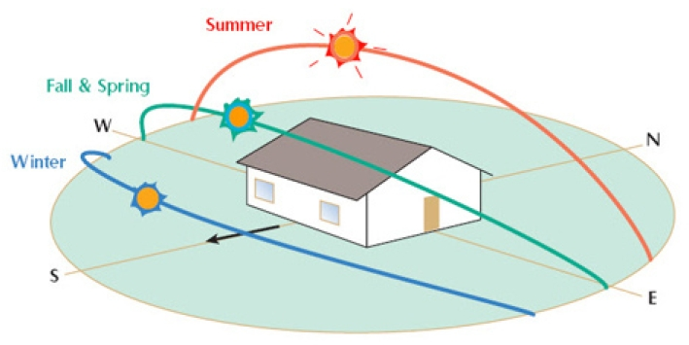
3. What do I want to grow?
   1. Since we’re two weeks behind, it’s best to aim for easy vegetables:
      1. Tomatoes
      2. Cucumbers
      3. Chillies
      4. Peas
4. Soil, seed, and water
   1. Get organic soil as it’s better.
   2. Find out the difference between normal soil and organic soil
   3. Get a seed starter!
      1. When you get the spoil, put it in a bowl/container and poor boiling water in it, then you can plant the seed
5. Know what you’re going to plant in
   1. Must have drainage hole🡪 very important for Nicolas if he’s designing the container.
      1. Find out how big those draining holes must be
   2. Must the container be self-created?
6. Know when to plant
   1. Find the growing season for the crops Massachusetts
   2. First and Last Frost Date
      1. First Frost Date is the first likely day the temperature will go below freezing
      2. Last frost date is the last likely day the temperature will go below freezing
7. Label your seeds
8. Plant 2 or 3 seeds on a container
   1. All seeds germinate at different times
      1. Germinate: (of a seed or spore) begin to grow and put out shoots after a period of dormancy. AKA “sprout”.
   2. Keep in darkness until seed sprouts
9. Tips
   1. Plants must be close to light. Must have light source for at most 16 hours
   2. If two plants sprout out, cut the one that’s the weakest
10. Seed buying
    1. Non-GMO: non genetically modified organisms
    2. Ai-lum: for many years have been consistently producing good crops

Notes: